REDAA Grant Call 1:
Project Grants - Stage 1 Concept Notes
Application questions
For reference use only. Submissions must be made via an online form on the IIED Flexi-Grant portal.

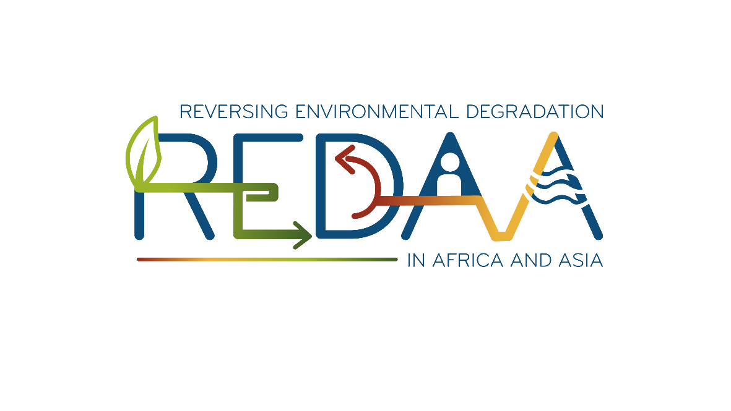

This Word version of the online application form is for drafting purposes only and has been developed to help applicants collaborate on their applications. Word limits must be respected and will be strictly enforced in Flexi-Grant. Please ensure you check all content when transferring across.
Submit your application via an online form on Flexi-Grant (https://grants.iied.org) by Monday 31 July 2023, 23:59 British Summer Time (UTC+1)
Please read the ‘Guidance for Applicants’ document available on the REDAA website (www.redaa.org/grant-call-1-resources) before drafting your answers.
Questions marked with an asterisk (*) are mandatory and must be answered.



REDAA is funded by UK International Development from the Foreign, Commonwealth and Development Office and managed by the International Institute for Environment and Development.
PAGE 1 OF 5: APPLICANT DETAILS
This section asks for details of the Lead Applicant (the individual person leading the project and taking overall responsibility for the project and this proposal); the Lead Organisation which would hold the grant agreement; and any Partner organisations that have already been identified.

Please enter the contact details for the Lead Applicant *

Title | Sir, Mr, Mrs, Miss, Ms, Dr, Prof, etc.
First name (must be the same name as the Flexi-Grant account holder)
Last name (must be the same name as the Flexi-Grant account holder)
Position
Related organisation
Preferred contact number (please include the country dialling code) *
Alternative contact number (please include the country dialling code)
Email (All email correspondence with the Lead Applicant will be sent to the email address listed here) *
Website
Address *

Position *
Provide the current job title of the Lead Applicant.

Secondary email address
You may wish to provide an alternative email contact to be copied into correspondence.
This can be a second email of the Lead Applicant, or the email of a colleague. Correspondence regarding the proposal will be copied (CC'd) to this email address.

Secondary phone number
You may wish to provide an alternative telephone contact.
Please include the country dialling code.

Lead Organisation details *
Provide full contact details for your organisation, including a website, contact number with full country code.

Name *
Preferred contact number (please include the country dialling code) *
Alternative contact number (please include the country dialling code)
Email *
Website
Address. This should be the legally registered address of the Lead Organisation. *

Lead Organisation acronym
Provide the short name/acronym of the Lead Organisation, if applicable.

(20 words max)

Lead Organisation type (dropdown choice in the Flexi-Grant portal) *

Non-governmental organisation (NGO) or civil society organisation (CSO) | Yes / No
International non-governmental organisation (INGO) | Yes / No
Government agency or department | Yes / No
Community-based organisation (CBO) | Yes / No
Indigenous People’s Organisation | Yes / No
University or other academic institution | Yes / No
Research institute of think tank | Yes / No
Private sector company | Yes / No
Other | Yes / No

Government agencies and departments are not eligible to lead on proposals or to receive REDAA funding, although they can be named as in-kind partners on proposals led by non-profit organisations.
Applications received with government agencies or departments named as the Lead Organisation will be rejected.

Private sector organisations are not eligible to lead on proposals, although they can be named as partners and receive funding via a non-profit Lead Organisation.
Applications received with private sector organisations named as the Lead Organisation will be rejected.

Location - Region (dropdown choice in the Flexi-Grant portal) *

South Asia | Yes / No
Southeast Asia | Yes / No
Sub-Saharan Africa | Yes / No
Asia – Other | Yes / No
Australasia and Oceania | Yes / No
Europe | Yes / No
North Africa and Middle East | Yes / No
North America | Yes / No
Central & South America and Caribbean | Yes / No
North America | Yes / No
Central & South America and Caribbean | Yes / No

Location - Country (dropdown choice in the Flexi-Grant portal) *
Select the country in which the Lead Organisation is legally registered.

Partner organisations
This section asks for details of organisations that you will partner with to deliver the project. If partner organisations have not yet been identified/confirmed, you can leave this section blank and provide the details at Stage 2 (Full Proposal).

Partner organisations
Provide the details of partner organisations using the following format:
Name of partner organisation - the country in which it is located (ABC Org - France)

(You can add additional partner organisations in the Flexi-Grant portal by using the + icon. Please use the same format as above for each new partner organisation.)

PAGE 2 OF 5: ELIGIBILITY SCREENING
The questions in this section will be used to screen for your organisation's eligibility to receive a REDAA grant for the proposed project. Please make sure you have read the Guidance for Applicants and the REDAA Strategy documents to check your eligibility before applying.

Other UK government funding *

Have you previously received or applied for funding for this project (or a very similar one) from other UK government funding sources? (tick box in the Flexi-Grant portal) | Yes / No

Subsequent questions if the answer to the above question is “Yes”
Other UK government funding
Provide the name of the funder, the funding scheme, grant reference and status of the application in the following format:
Funder name - Funder scheme - Funder grant reference - application status

(200 words max)
(You can add additional funder details in the Flexi-Grant portal by using the + icon. Please use the same format as above for each new funder details.)

(200 words max)

Other UK government funding - Additional details
Provide any additional information relating to the funding reported above.

Turnover *
What was the Lead Organisation's average annual turnover/income in GBP over the last three financial years?
The expected annual expenditure on the proposed project should not exceed 25% of the Lead Organisation’s average annual turnover/income.
Please convert the figure to GBP using today's exchange rates on OANDA.com (https://www.oanda.com/currency-converter)

Annual audit reports upload
Attach the last 3 annual audit reports.
Acceptable formats .doc, .docx, .pdf

Annual audit reports upload explanation
If you are unable to provide the last three annual audit reports, please provide a brief explanation here.

(50 words max)

PAGE 3 OF 5: PROJECT SUMMARY DETAILS
This section asks for high-level summary details of your proposed project.

Project title *
Provide a short but descriptive title for your project which conveys what the project is about.

(20 words max)

Project summary *
Provide a brief summary of your project, describing: the problem it is trying to address, its aims, and the key activities you plan to undertake.
Write this section for a non-technical audience, using simple, jargon-free language.

(100 words max)

REDAA outputs *
Which of the main REDAA outputs will your project contribute to? (tick box in the Flexi-Grant portal)
Please refer to the REDAA Strategy for the full description of each output.

OUTPUT 1: Evidence & actionable information | Yes / No
OUTPUT 2: Technical approaches and tools | Yes / No
OUTPUT 3: Capacity and institutional arrangements | Yes / No

OUTPUT 1: Evidence & actionable information *
Briefly explain how your project contributes to this output. If you have not selected this output, respond with N/A.

(100 words max)

OUTPUT 2: Technical approaches and tools *
Briefly explain how your project contributes to this output. If you have not selected this output, respond with N/A.

(100 words max)

OUTPUT 3: Capacity and institutional arrangements *
Briefly explain how your project contributes to this output. If you have not selected this output, respond with N/A.

(100 words max)

Project location - Focal region *
Which REDAA focal region will your project be working in?
(tick box in the Flexi-Grant portal)

South Asia | Yes / No
Southeast Asia | Yes / No
Sub-Saharan Africa | Yes / No
South Asia / Southeast Asia | Yes / No
South Asia / Sub-Saharan Africa | Yes / No
Southeast Asia / Sub-Saharan Africa | Yes / No
South Asia / Southeast Asia / Sub-Saharan Africa | Yes / No

Project location *
Select which countries will your project be working in? Select all relevant countries
(in the Flexi-Grant portal,
- the countries available will depend on the answer chosen from the previous question (region),
- the answers will be as tick boxes)

South Asia
Bangladesh | Yes / No
Bhutan | Yes / No
India | Yes / No
Maldives | Yes / No
Nepal | Yes / No
Pakistan | Yes / No
Sri Lanka | Yes / No

Southeast Asia
Cambodia | Yes / No
Indonesia | Yes / No
Lao People's Democratic Republic | Yes / No
Malaysia | Yes / No
Myanmar | Yes / No
Philippines | Yes / No
Thailand | Yes / No
Timor-Leste | Yes / No
Viet Nam | Yes / No

Sub-Saharan Africa
Angola | Yes / No
Benin | Yes / No
Botswana | Yes / No
Burkina Faso | Yes / No
Burundi | Yes / No
Cabo Verde | Yes / No
Cameroon | Yes / No
Central African Republic | Yes / No
Chad | Yes / No
Comoros | Yes / No
Congo | Yes / No
Côte d’Ivoire | Yes / No
Democratic Republic of the Congo | Yes / No
Djibouti | Yes / No
Equatorial Guinea | Yes / No
Eritrea | Yes / No
Eswatini | Yes / No
Ethiopia | Yes / No
Gabon | Yes / No
Gambia | Yes / No
Ghana | Yes / No
Guinea | Yes / No
Guinea-Bissau | Yes / No
Kenya | Yes / No
Lesotho | Yes / No
Liberia | Yes / No
Madagascar | Yes / No
Malawi | Yes / No
Mali | Yes / No
Mauritania | Yes / No
Mauritius | Yes / No
Mozambique | Yes / No
Namibia | Yes / No
Niger | Yes / No
Nigeria | Yes / No
Rwanda | Yes / No
São Tomé and Príncipe | Yes / No
Senegal | Yes / No
Sierra Leone | Yes / No
South Africa | Yes / No
South Sudan | Yes / No
Tanzania | Yes / No
Togo | Yes / No
Uganda | Yes / No
Zambia | Yes / No
Zimbabwe | Yes / No

Project start date
All projects must start on the 1 January 2024, they cannot start outside this window.

Project end date *
Enter the proposed end date for your project. Projects should be between 2 and 4 years in duration (min. allowable value 31/12/2025 and max. allowable value 31/12/2027)

Project budget *
Provide the total amount in British Pound Sterling (GBP) that you are requesting from the REDAA grant fund.
This figure should be between £200,000 and £500,000. Please do not include any proposed co-funding / matched funding in this figure.

PAGE 4 OF 5: PROJECT DETAILS
This section asks for more detail about your proposed project - what it seeks to achieve, and how it will go about it.

Problem / Opportunity *
Please describe the problem that your project seeks to address (and/or the opportunity it seeks to seize). Specifically: What is the environmental degradation issue? Is this problem happening in a specific ecosystem or landscape? If so, which ecosystem(s) and/or landscape(s) are relevant?

(100 words max)

Background / Context *
Please provide some background/context to this problem. For example: Why is the problem important or particularly relevant now? What previous research has been conducted on the problem, and how will your proposed project build upon that?
If you cite other work in this section, please ensure you upload a reference list as an attachment [Max. 1 page] at the end of the application form.

(250 words max)

REDAA Research-to-action priorities *
Please select which of the five REDAA research-to-action thematic priorities your project aims to address/contribute to. Please refer to the REDAA Strategy for further details on the thematic priorities before making your selection. (tick box in the Flexi-Grant portal)

Local research and capability for research | Yes / No
Resource and land use assessments | Yes / No
Business models | Yes / No
Financing mechanisms | Yes / No
Inclusive governance systems | Yes / No

Objectives and outcomes *
Please describe the main objectives of your proposed project and expected outcomes.

(250 words max)

Project impact – Nature *
Describe the planned impacts/longer-term changes expected from your project on nature (e.g. biodiversity, ecosystems, environmental/ecological issues).

(100 words max)

Project impact – Climate *
Describe the planned impacts/longer-term changes expected from your project on climate (e.g. climate mitigation, adaptation).

(100 words max)

Project impact – People *
Describe the planned impacts/longer-term changes expected from your project on people (e.g. social equality and inclusion, livelihoods).

(100 words max)

Methods & activities *
Describe the methods, approaches and activities your project will use to fulfil the objectives and achieve the intended outcomes and impacts. How will you undertake the work (materials and methods)? Are the methods tried and tested / best practice in the field, or are they new, innovative or experimental?

(500 words max)

Gender Equality and Social Inclusion *
Please explain how the project will address gender and other social equality issues. Please situate your response in the local/national/regional context as applicable so that it is clear what the relevant issues are and how your project will address these.

(250 words max)

Locally led research-to-action *
Explain how the project will fulfil the requirement to be "locally led". What does this mean to you, within the context of your project? Who are the key local stakeholders? Who are the main beneficiaries? How will they be engaged? What kind of organisations will you work with, and at what level do they operate (e.g. local, national)? Will you work with any Indigenous Peoples & Local Communities?

(250 words max)
PAGE 5 OF 5: SUPPORTING DOCUMENTS AND DECLARATION
On this page you will be asked to confirm your commitment to the project and to confirm that the details provided in the application are a fair and accurate representation of the proposed project. You can also upload any supporting documentation.

Supporting documents
If you cited other work in your responses, please upload a reference list as supporting documentation (max 1 page).
Acceptable formats: .doc, .docx, .pdf

Lead Applicant declaration *
As the Lead Applicant for this proposal, I confirm that the information provided is accurate and truthful to the best of my knowledge. I confirm that my organisation (department head/director) is aware of this proposal and has provided the appropriate approvals for me to submit the proposal for consideration on behalf of the organisation.
Tick box

Submission deadline
Concept Note applications must be submitted via an online form on Flexi-Grant before the deadline of 31 July 2023, 23:59 British Summer Time (UTC+1). Applications received after this date will not be considered. We recommend submitting in advance of the deadline in case of technical issues, as the helpdesk will not be staffed outside normal UK office hours.

